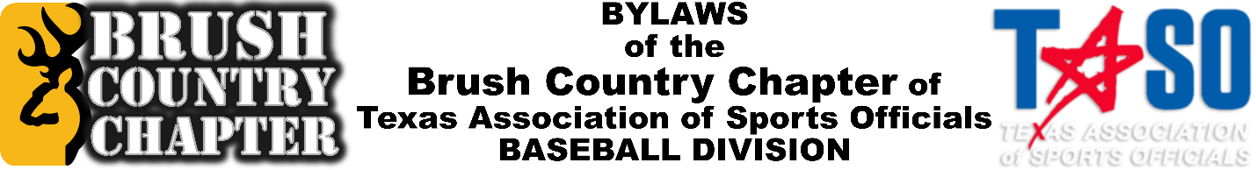

January 27, 2021

“Play Ball,” Brush Country Umpires,
We are greatly encouraged & excited for the 2021 Season to get under way as we begin to inch closer to calling the “Bang-Bang” plays at 1B, the “BY RULEs” on appeals, the Balks and the Called Strike 3’s that gives us a name to a coach.
Below is the meeting schedule for the coming 2021 Season. All meetings are mandatory—that is only nine total. There may be other training meetings that members are encouraged to attend.
Since this is a COVID-19 2021 Season, all meetings will be held by WebEx until future notice, BUT (if &) when, we resume in person meetings, they will be held at the Pleasanton Civic Center, 115 N. Main Street, Pleasanton, TX 78064.
In addition, we ask that your register on our website @ www.BrushCountryUmpires.org for behind the scenes access to these meetings that will be made available via our YouTube Channel. When you register for a BCU Account through our website, your will receive a direct email link to the recorded meeting for viewing to receive credit for that meeting. A set of 3 codes will be embedded into the Recorded Meeting for reporting to our Secretary, Jeff Niemietz via text, email, or phone call. We are trying everything we can to facilitate your involvement and completion of meeting requirements.
Remember: You must attend 75% of these mandatory meetings to be eligible for playoffs! That is only six (6) of the eight (8) possible meetings.
*******************************************************
2 February, Tuesday
- Board Meeting, 5:30 pm
- General Meeting, 6:30 pm
8 February, Monday
- Board Meeting, 5:30 pm
- General Meeting, 6:30 pm
*** 6-20 February — Scrimmage Season ***
22 February, Monday — Regular Season Begins ***
- Board Meeting, 5:30 pm
- General Meeting, 6:30 pm

8 March, Monday — DEADLINE for New Members & to take TASO Test!
- Board Meeting, 5:30 pm
- General Meeting, 6:30 pm
22 March, Monday
- Board Meeting, 5:30 pm
- General Meeting, 6:30 pm
5 April, Monday
- Board Meeting, 5:30 pm
- General Meeting, 6:30 pm
*** 1st round of nominations (VP, Secretary, Assigner, All Classification Representatives)
19 April, Monday
- Board Meeting, 5:30 pm
- General Meeting, 6:30 pm
*** 3- and 4-umpire training, required to be playoff eligible
*** 2nd round of nominations (VP, Secretary, Assigner, All Classification Representatives)
26 April, Monday — PLAYOFF TRAINING
(NOTE: Optional meeting scheduled to facilitate 3- and 4-umpire training for Playoffs.)
- On-Field Meeting, site to be announce __________________ @ 7pm
- 3- and 4-Umpire Training, Required for Playoff Eligibility
3 May, Monday
- Board Meeting, 5:30 pm
- General Meeting, 6:30 pm

*** 1st or 2nd Week of May — First round of playoffs ***
17 May, Monday (final meeting of 2020 season)
- Board Meeting, 5:30 pm
- General Meeting, 6:30 pm
*** Elections (Vice President, Secretary, Assigner, All Classification Representatives)
Final Reminder: You must attend 75%, or six (6) of the possible eight (8) mandatory meetings to be playoff eligible! The earlier, the better for you & us.
God bless each of you this year ahead, and have a GREAT 2021 Season!
Brush Country Umpires
Robert Redding, Robert Hargrove, Jeff Niemietz, Jonathon Goff, Tomas Rodriguez, Frank Lopez, Xcaret Ramirez, Tim Pimental, Abe Kumaus, & Joseph Cruz with Jim Murray and Gabriel “Toro” Hernandez

Edited By: | Date: | Notes:
Robert Redding | January 7, 2020 | Created by RR for the 2020 season.
Joseph Cruz | January 27, 2021 | Re-written for preliminary use for the 2021 season.
Joseph Cruz | January 28, 2021 | Edited with Robert Hargrove via phone & send to Jeff Niemietz for updating info.

